Category product – website
Section-2

- Aldrop
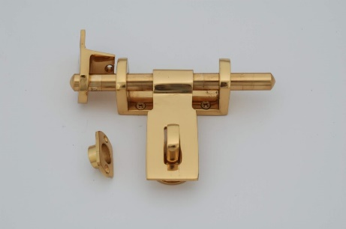

Sub category | Features | sizes | color | brand | Price , size
Gajana |  | 8 inch | Black | AKS | 430 8inch , 6inch
Elando |  | 10 inch | Antic | Hanoi | 480 8inch , 6inch
SDC |  | 6inch | Gold | Magnum | 1620 8inch , 6inch
Audi |  | 24 inch | Zinc | Plus point | 800 8inch , 6inch 12
 |  |  |  | Rajen, Taj | 630 8inch , 6inch

- Auto hinges
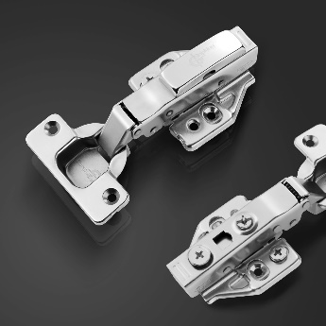

category | Sub category | Features – (sub category) | sizes | color | brand | Price
Regular hinges | 0 crank, 8 crank , 16crk , 165crnk | Regular hinges – 0 crank, 8 crank | 35x11.5mm  ø 35 mm | SS (Satin) | Yale | 360
Soft close hinges | 0 crank, 8 crank | Soft close hinges – 0 crank , 8 crank | 250mm | Black , ss | Hafele | 380
Folding hinges (Soft close regular) |  | Folding hinges (Soft close regular) | 35x11.5mm | Zinc , blk | Ebco | 1560
Blind corner hinges |  | Blind corner hinges | 35x11.5mm | Antic , ss, | yale | 780

- Hinges
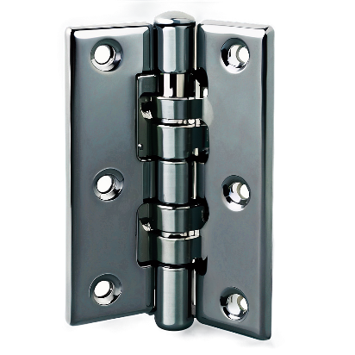

category | Sub category | Features – (sub category) | sizes | color | brand | Price
L’ Hinges | Lock & unlock hinges | Lock & unlock hinges | 3" x 7/8" ,(22mm) x 1/8",  4’*7/8(22) ,  x 1/8",  5’*7/8(22)  x 1/8",  6’*7/8(22) | Black ,  An,  Ss,  gold | Magnum | 588  600  700  789
Duck L hinges or Overlay | Off Hinges, full hinges | Off Hinges, full hinges | 3" x 3/4" (19mm) x 1/12"  4’*7/8(22) ,  x 1/8",  5’*7/8(22)  x 1/8",  6’*7/8(22) | Antic | Ideal | 232
Butt & Cutt hinges |  |  | 3X1/2X3/4 X  4’*7/8(22) ,  x 1/8",  5’*7/8(22)  x 1/8",  6’*7/8(22)  3/32 | Rose gold | Ideal | 120
Railway Hinges | Regular hinges | Regular hinges | 6" x 1" (25mm) x 1/8",  7" x 1" (25mm) x 1/8"  7" x 1" (25mm) x 1/8" | Satin (SS) | Magnum | 972
Bearing Hinges |  |  | 3" x 2.1/2" x 3mm | Matt black | Magnum | 622
Parliament Hinges |  |  | 3 X 3 X 4MM | black | Ideal | 880
Spring hinges | Double Action hinges , Single Action hinges | Double Action hinges , Single Action hinges | 6" x 3"x 4mm | Antic | Magnum | 522
SOSS hinges |  |  | 5" x 3.1/2" x 5mm | Satin (ss) | Ideal | 855
3D hinges |  |  | 6" x 4" x 5mm ,  5*4*8  9*9*8 | Black ,  Ss  Ab | Ideal , magnum | 625
Crown Hinges | Left & Right hinges | Left & Right hinges | 3X3/4X1.5 ( L & R ) | Rose gold | Ideal , magnum | 220

- Telescopic Drawer
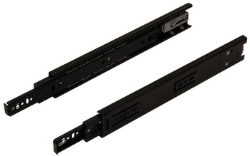

Sub category | Features | sizes | color | brand | Price
Regular drawer slide |  | 300 mm & 10inch , 400mm & 12inch , 500mm 14inch | Zinc plated white ,  Blk . | EBCO ,  Haffele,  Doorset | 1598,  348,  789.
Soft close drawer slide |  | 285 mm ,  10inch , 400mm & 12inch , 500mm 14inch | Black , white | EBCO ,  Haffele,  Doorset | 702,  798,  456
Heavy duty drawer slides |  | 450 mm / 90 Kg | Brown , white | EBCO,  Haffele,  Doorset | 1598.  1680.  1234

5) Tower Bolt
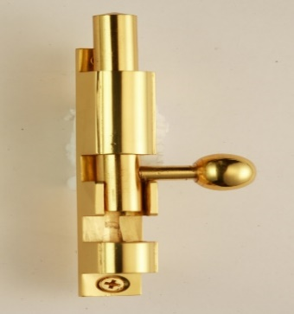

category | Features – | sizes | color | brand | Price
ZYLO |  | 4” , 6” , 8”, 10” | Antic | Magnum , ideal , aks, princess | 588 , 123,789,588
Round tower bolt |  | 18”, 24”, 36” | Antic ,Black | Labacha , Magnum , ideal , aks, princess | 456, 123,789,588
Neck tower bolt |  | 18”, 24”, 36” | Rose gold , Antic | IDEAL, Magnum , ideal , aks, princess | 545, 123,789,588
CONCEALED & flush tower bolt |  | 10”, 12”,15”,18” | Satin (ss) , Antic | Magnum , ideal , aks, princess | 735, 123,789,588
D' TYPE LIGHT tower bolt |  | 18”, 24”, 36” | Graphite, Antic | Magnum , ideal , aks, princess | 604, 123,789,588
A' type surface bolt |  | 10”, 12”,15”,18” | Matt black, Antic | Magnum , ideal , aks, princess | 938, 604, 123,789,588
Super neck tower bolt |  | 10”, 12”,15”,18” | Black  , Antic, ss | Magnum , ideal , aks, princess | 1163, 604, 123,789,588
Off round tower bolt |  | 18”, 24”, 36” | Graphite blk, ss , rose gold | Magnum , ideal , aks, princess | 840, 604, 123,789,588
Capsul tower bolt |  | 4” , 6” , 8”, 10” | Rose gold | Magnum , ideal , aks, princess | 670, 604, 123,789,588
Normal tower bolt |  | 18”, 24”, 36” | Antic | Magnum , ideal , aks, princess | 953, 604, 123,789,588

- Door Closer
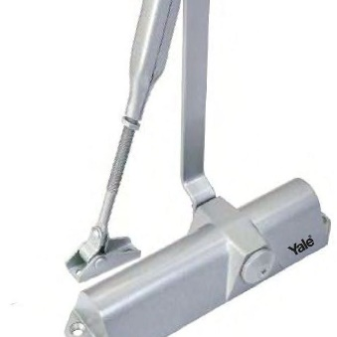

category | Features – (sub category) | sizes | color | brand | Price
Soft door closer | Soft door closer | 70Kg | Anthracite | EBCO, Hafele | 1550
Regular door closer | Regular door closer | 85 Kg | Sliver | EBCO, Hafele | 2336
Hold open door closer | Hold open door closer | 40-80 Kgs | Black | Hafele, Hafele | 7995
Box door closer | Box door closer | 60Kg | Black | GEZE, Hafele | 1732

- Door Stopper & door magnet
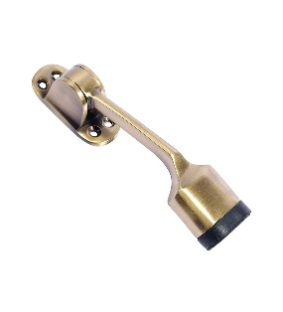
category | Features – (sub category) | sizes | color | brand | Price
FLOOR-STOPPER |  | 4inch , 8inch , 10inch H 120 x Ø 26mm | Antique brass , Blk | Magnum , SMF, rajan | 883 , 123,489
Half moon door stopper |  | 4inch , 8inch , 10inch H 105mm x Ø 26mm | Satin, rose gld | SMF, rajan Magnum | 929,789.456
Magnetic door stopper |  | 4inch , 8inch , 10inch H 88 x Ø 45mm | Rose gold, Matt black | SMF, rajan,  Magnum | 1226,456,789

- Rim Lock
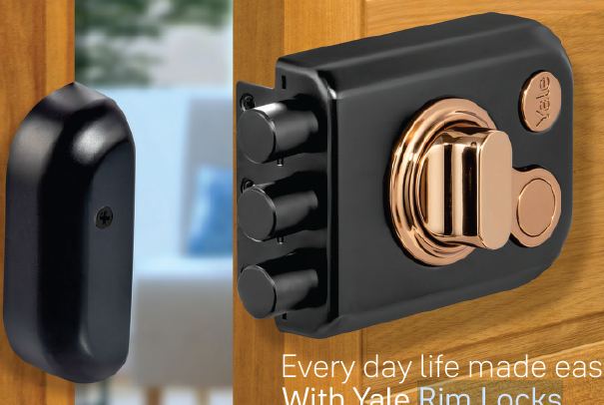

category | Features – (sub category) | sizes | color | brand | Price
KRATOS Series  CBD Series  CBR Series | 4 Dimple  Keys | KRT-LB-TT (XX)  KRT-3B-TT (XX)  KRT-3B-DC (XX) | SSM/BN ABM/BN BM/BN BM/RG RGM/RG | Yale, | ₹ 4,200  ₹ 4,410  ₹ 4,620  ₹ 4,620  ₹ 4,620
YE Series | 2 Deadbolts,  3 Deadbolts,  3 Deadbolts,  1 Deadbolt | YE-MDL-3B-DC-DK-IN  YE-MDL-3B-TT-DK-IN  YE-MDL-LB-TT-DK-IN  YE-NL-LB-TT-DK-IN | Ivory  Ivory  Ivory  Ivory |  | 2,620  2,310  2,360  1,890
Vertical Bolt Series |  | VB 100 TTDK (XX)  VB 100 DCDK (XX)  VBKA 100 DCDK (XX)  VBKA 100 TTDK (XX) | SIL  AB |  | 3,690, 3,970  7,920  4,250  8,500  7,380  4,110  8,220
Electric Rim Lock |  |  |  |  | 3,915  2,915  1,765  4,180

- sofa Leg
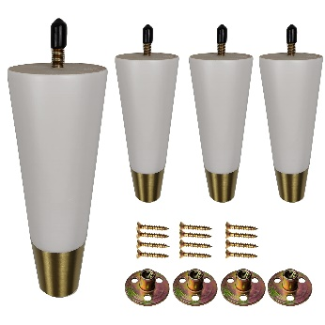

category | Features – (sub category) | sizes | color | brand | Price
Round |  | 120*120*100*1.8mm, 100 mm | Black, gold | EBCO | 450
Square |  | 120*120*100*1.8mm, 100 mm | Black, gold | EBCO | 552
 |  | 100 mm , 120*120*100*1.8mm | Black, gold | EBCO | 685
 |  | 120 mm , 120*120*100*1.8mm | Black, gold | EBCO | 741

10)Hooks
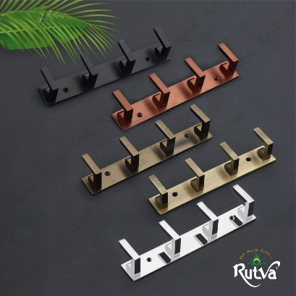

category | Features – (sub category) | sizes | color | brand | Price
Fancy Hook | Single , multiple hooks | 4 Hook, 8 Hook, 6 hook | Black, rose gold, Chrome | Rutva | 200,250,290
Coat hook | Single , multiple hooks | 4 Hook, 8 Hook, 6 hook | Black, rose gold,Chrome | Rutva | 300,320,210
J Hook | Single , multiple hooks | 4 Hook, 8 Hook, 6 hook | Black, rose gold, Chrome | Rutva | 200,250,290
Titanic hook | Single , multiple hooks | 4 Hook, 8 Hook, 6 hook | Black, rose gold,chrome | Rutva | 300,320,210
Elephant hook | Single , multiple hooks | 4 Hook, 8 Hook, 6 hook | Black, rose gold, chrome | Rutva | 200,250,290

11)Brackets
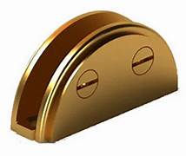
category | Features – (sub category) | sizes | color | brand | Price
D bracket |  | 2,4,6inch | Ss,ab,rs,crome | Rochess, labacha | 123.123,468
Table Folding bracket |  | 7,8,inch | Ss,ab,rs,crome | Rochess, labacha | 123.123,468
Square bracket |  | 7,8,inch | Ss,ab,rs,crome | Rochess, labacha | 123.123,468

12) Crystal collections
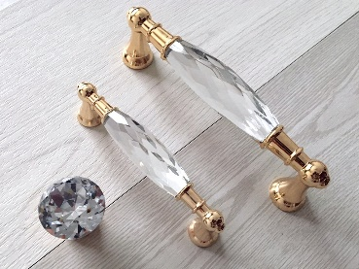

category | Features – (sub category) | sizes | color | brand | Price
Knobs |  | 2mm,4mm | Ss,ab,rs,crome | Rochess, labacha | 123,123,468
Handle’s |  | 2mm,4mm | Ss,ab,rs,crome | Rochess, labacha | 123,123,468

13)Lock collections or mortise lock body
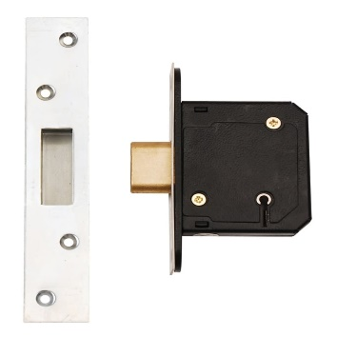

category | Features – (sub category) | sizes | color | brand | Price
Plate lock , | 3bullet,  2 bullet,  1 bullet | 200mm 400mm | Black, ss. An | Archis,  Yale, | 1522,1234
Double door | Cylindrical Lock,  Mortice latch,  Bullet lock  Dead lock |  | Black, ss. An

